Mini Project
Contact Centre WFM Analytics Power BI Visualization steps
Prepared by Ramya | 7 November 2026 | Tools: Microsoft Excel and Power Query Editor
Executive Overview
This document details the end-to-end steps performed by me to transform raw call centre operational files into an interactive, multi-tab Power BI dashboard. The project involved multi-source data ingestion, complex Power Query transformation, custom DAX measure development, relational data modeling, and tailored visual canvas configuration.
1. Dataset importing
Opened a blank Power BI Desktop report and connecting to the underlying operational data files.
- Blank Canvas Setup: Opened Power BI Desktop to access the primary data ingestion pane.
- Data Navigator: Selected the target Excel workbook containing workforce management and call logs.
- Table Selection: Loaded tables including Agent_Availability, Agent_Details, Call_Volume, Leave, Skills, QA_CSAT, and wfm_weekly_Forecast.
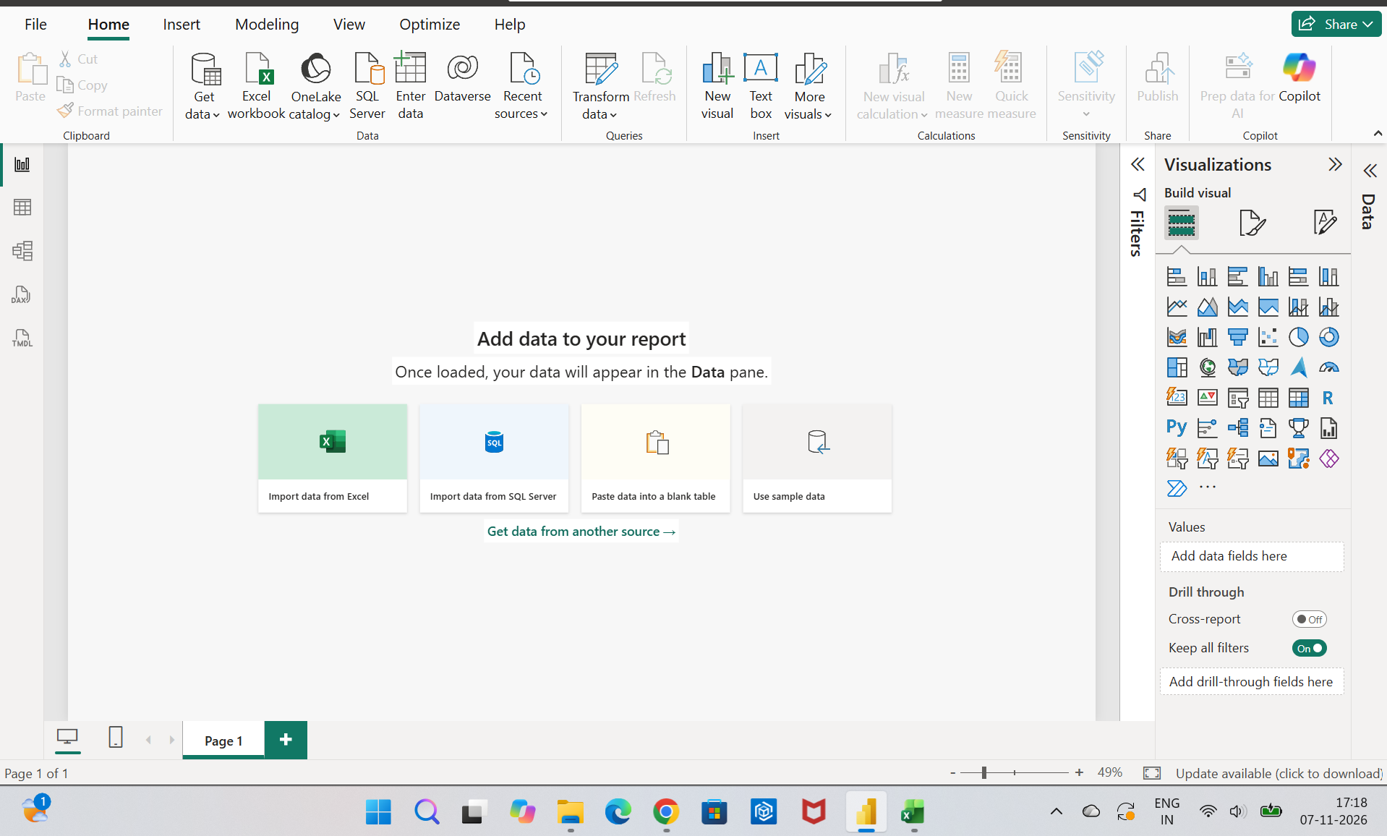

2. Data Transformation & Power Query Cleaning
To ensure reporting accuracy, I navigated to the Power Query Editor to perform column formatting, missing data handling, and table merging.
Key Transformations Applied:
- Data Type Adjustments: Converted date fields across tables into standardized Short Date formats (dd-mm-yyyy).
- Merging Queries: Merged Agent_Details with Agent_Availability using a Full Outer Join on AgentID.
- Data Cleanup: Applied operational filtering to remove blank rows and redundant duplicates, refining the dataset down to clean distinct records.
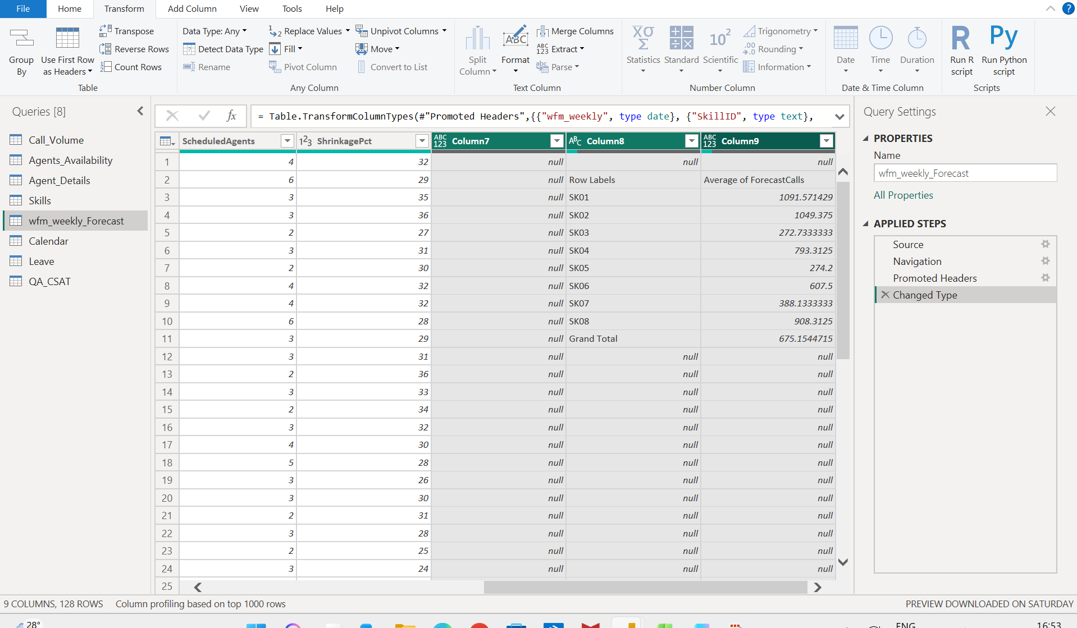

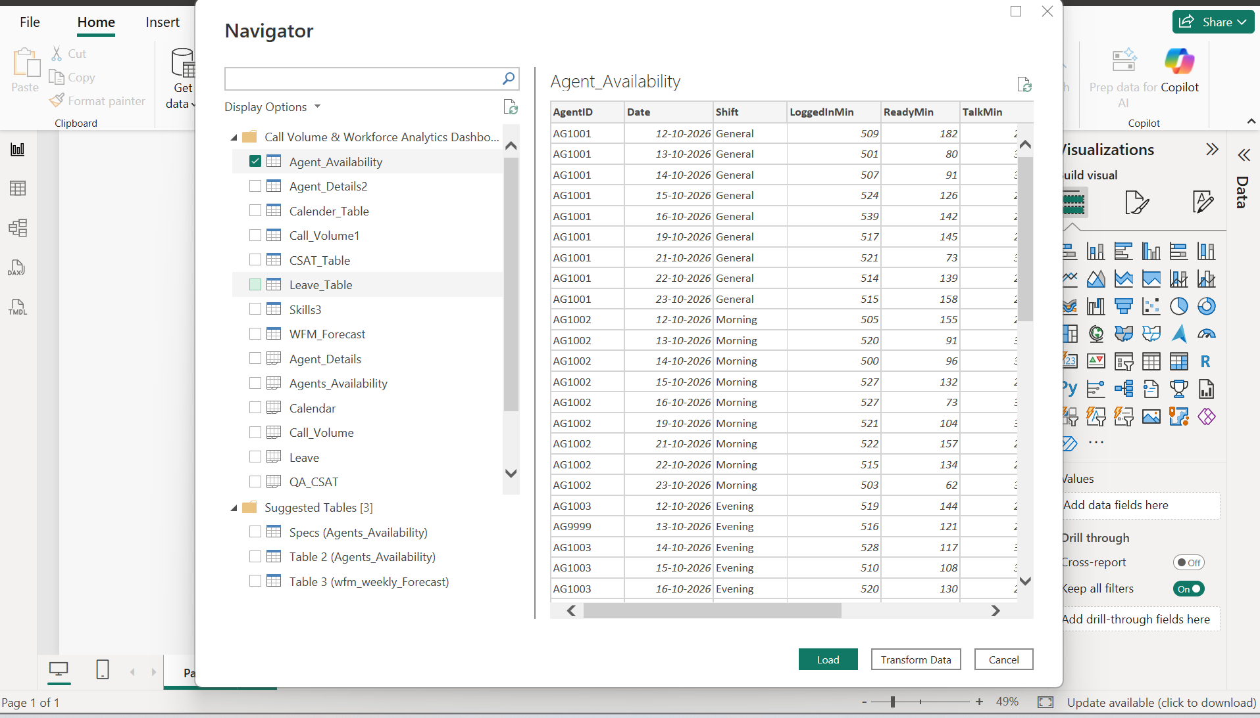

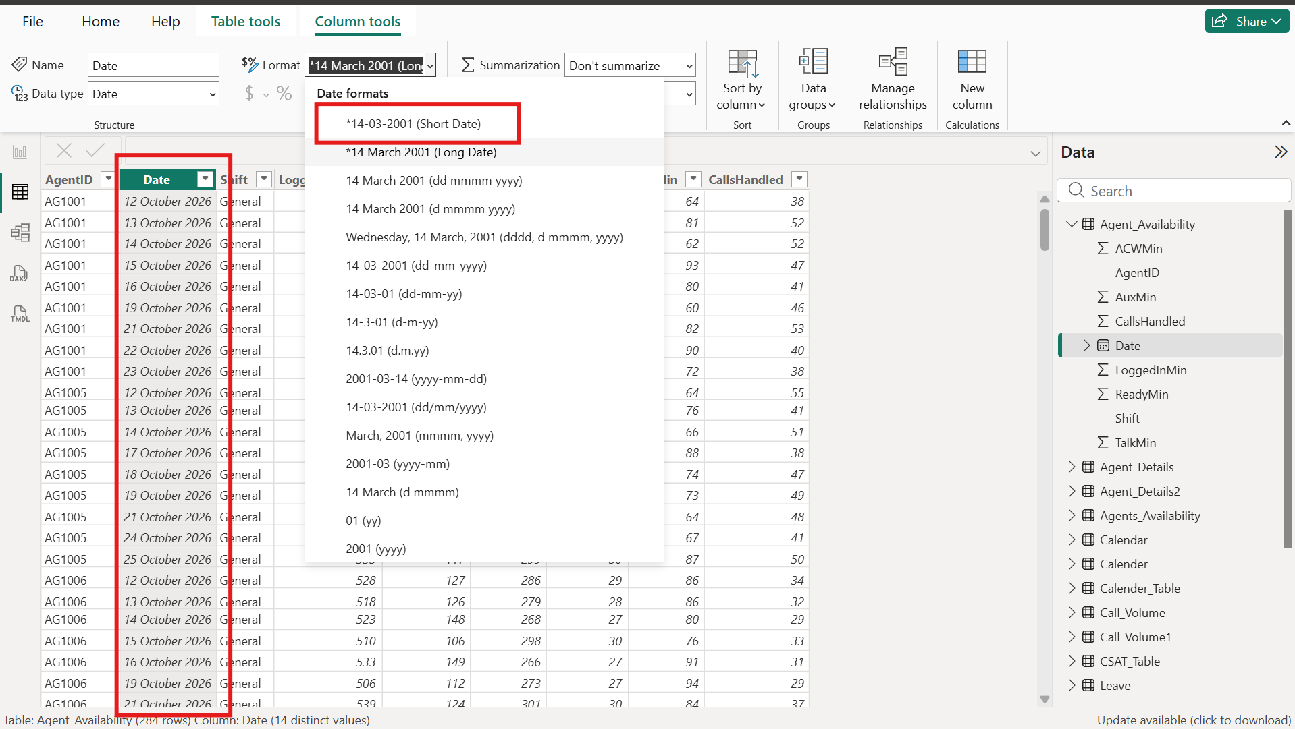

DAX Calculations
- Average Talk Time Column:Average Talk Time = DIVIDE(Agent_Availability[TalkMin], Agent_Availability[CallsHandled])
- Average ACW Seconds Column:AvgACWSec = (Agent_Availability[ACWMin] / Agent_Availability[CallsHandled]) * 60
- Agent Tenure Column:Tenurity = DATEDIFF(Agent_Details[HireDate], TODAY(), YEAR)
- Staffing Variance Column:Staffing Miss = WFM_Forecast[RequiredAgents] - WFM_Forecast[ScheduledAgents]
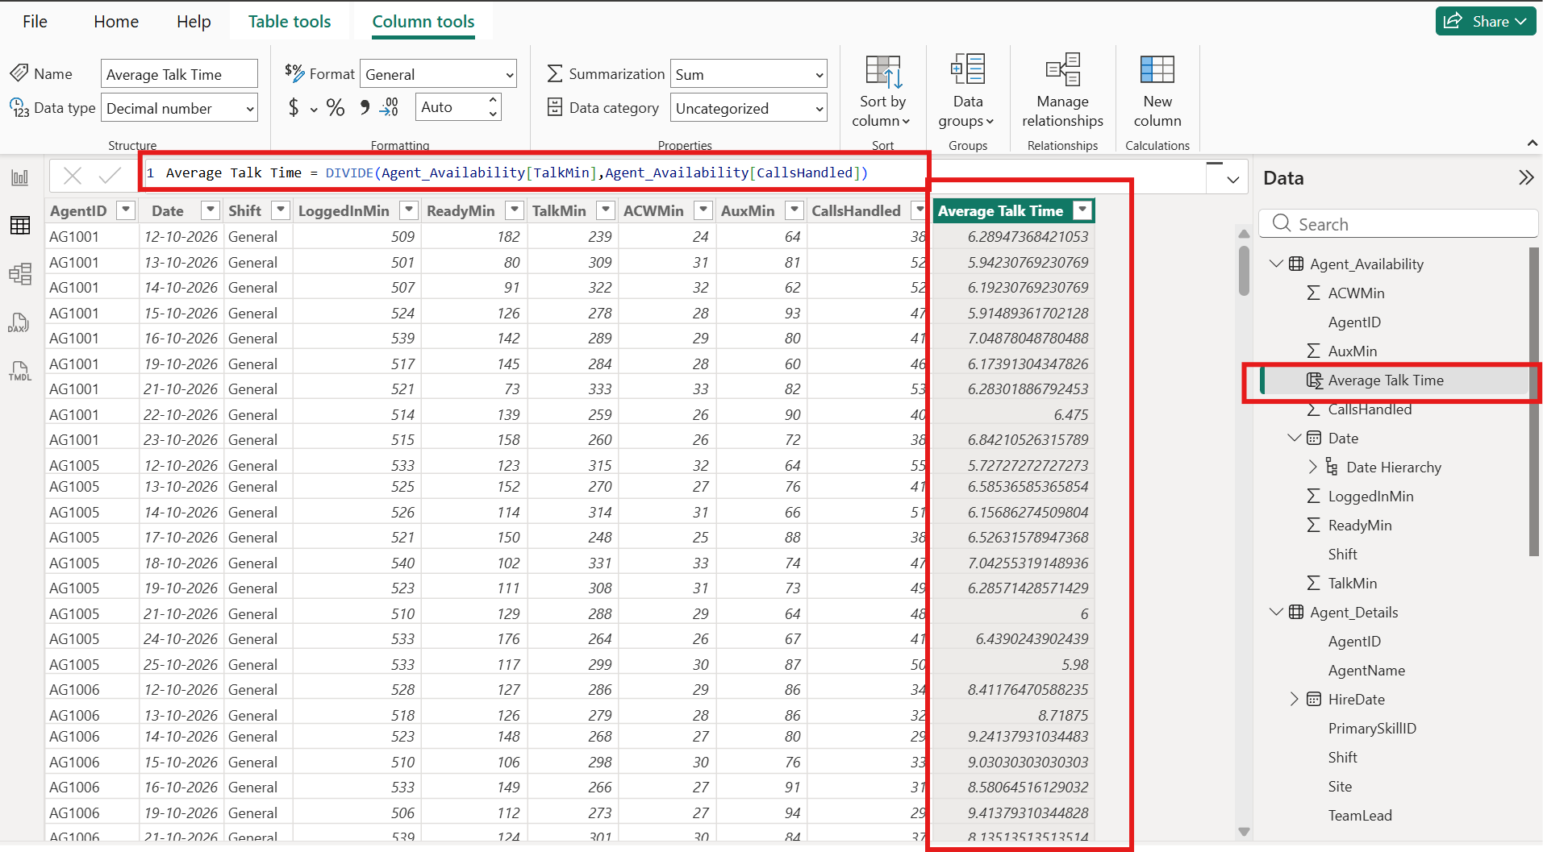

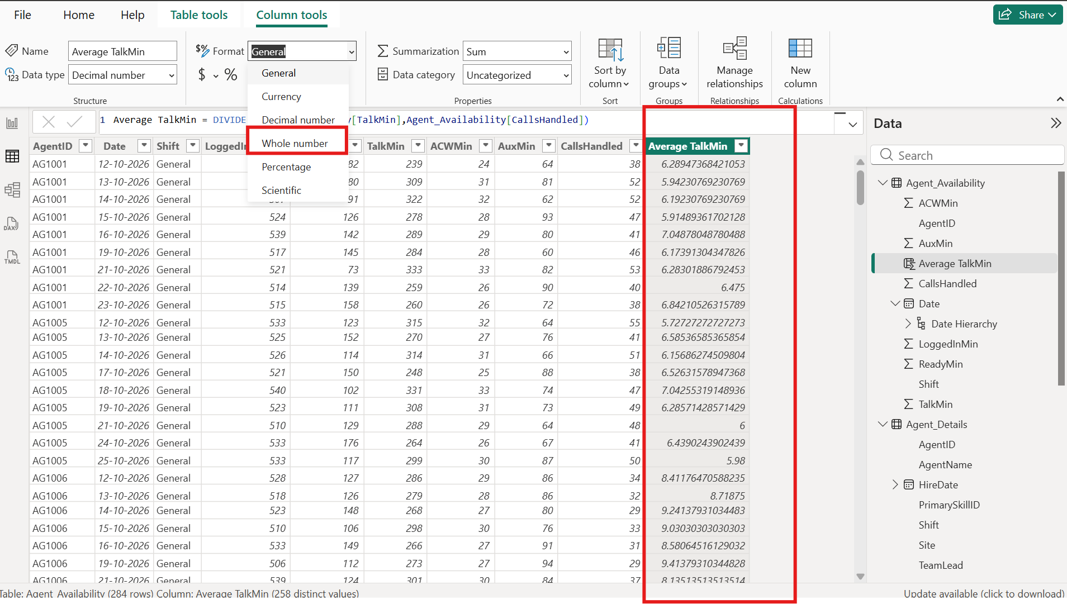

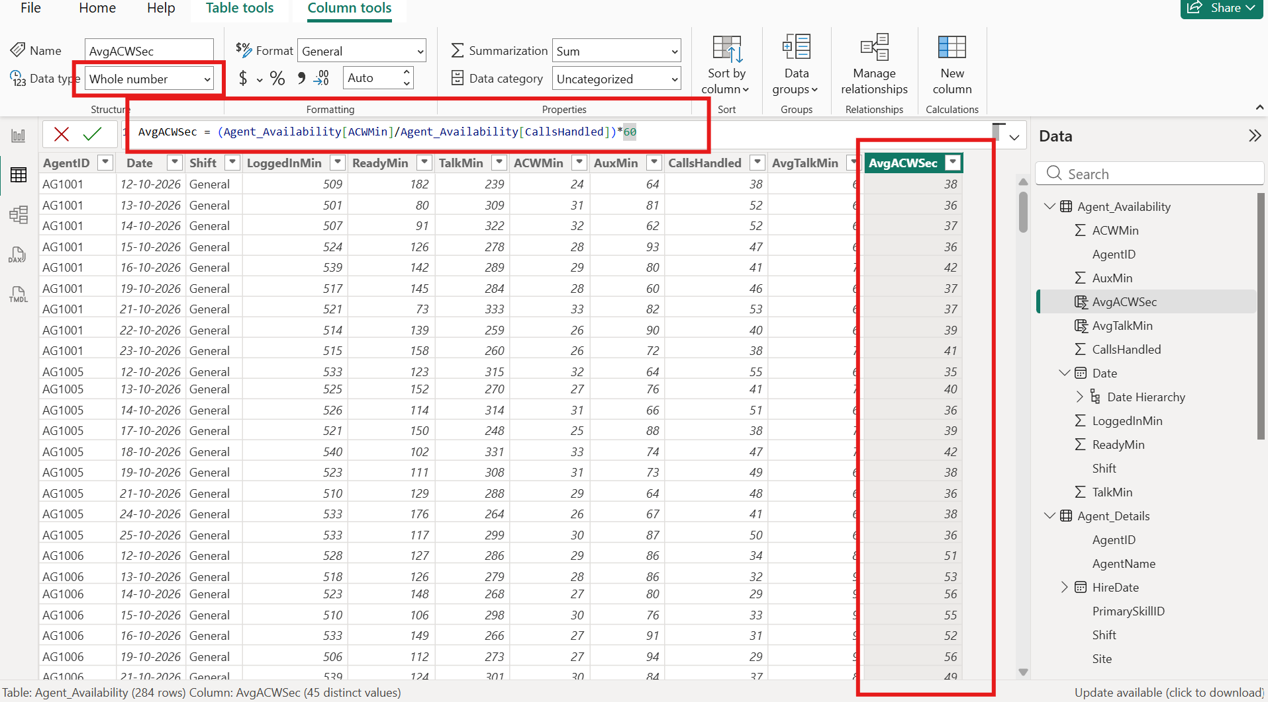

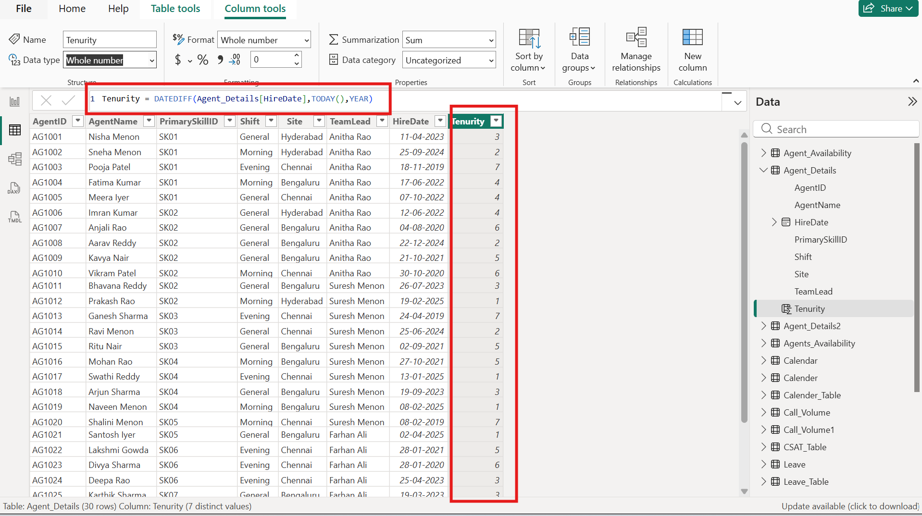

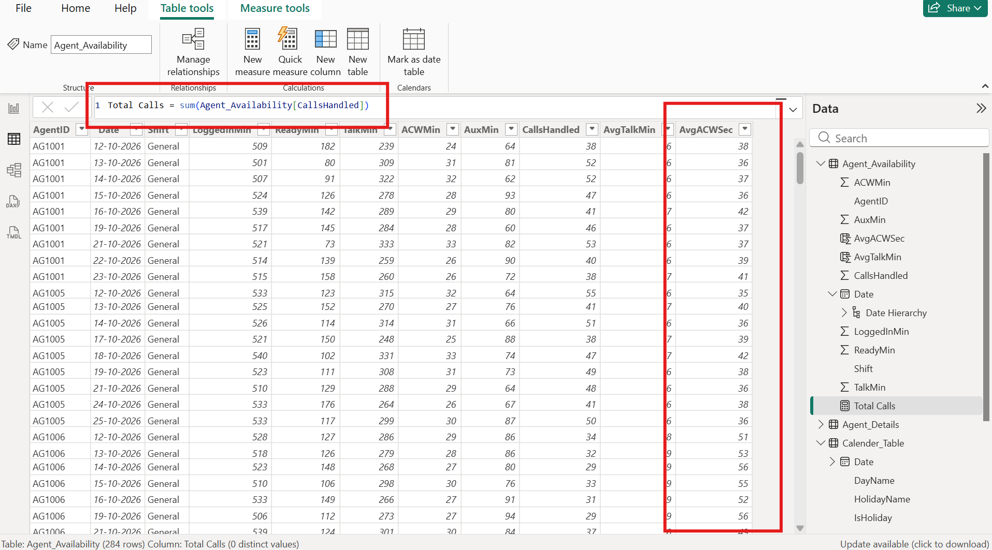

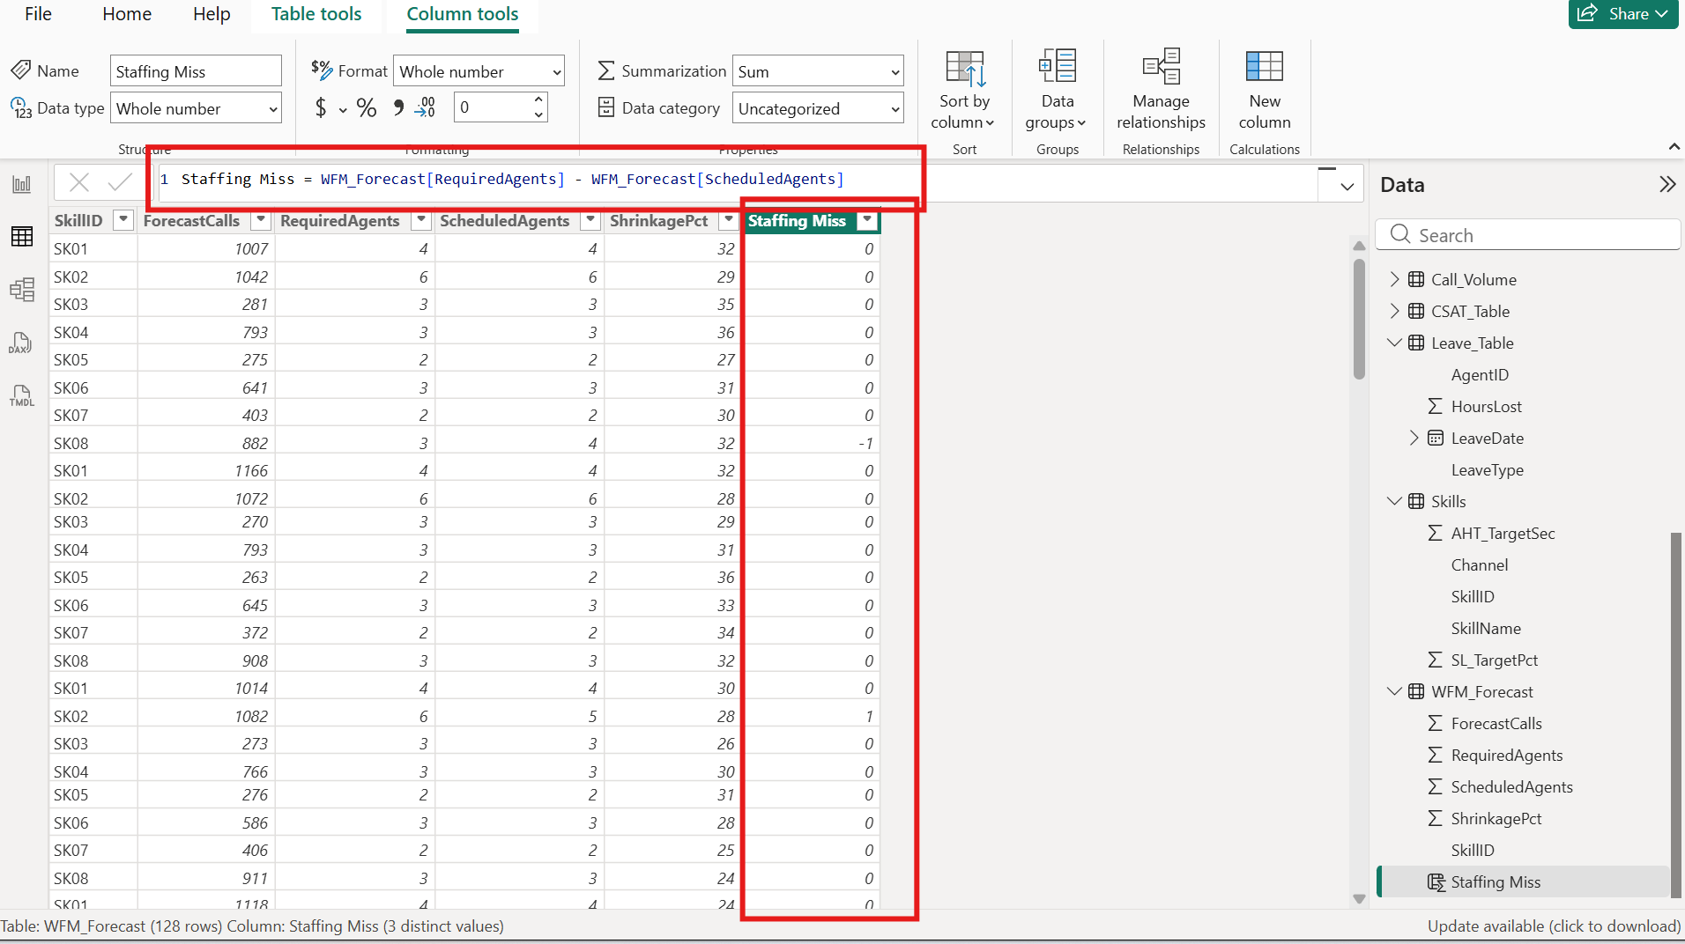

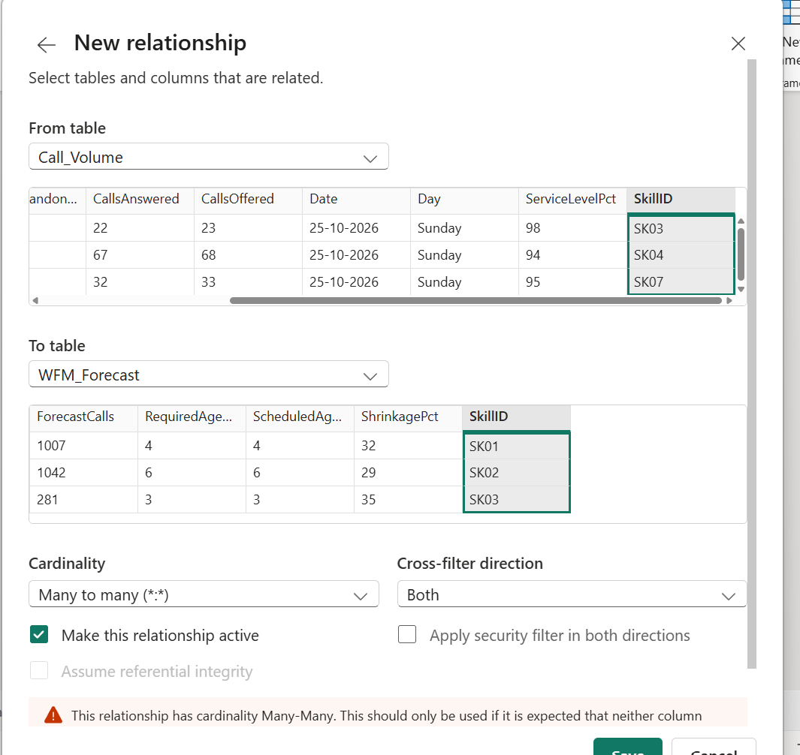

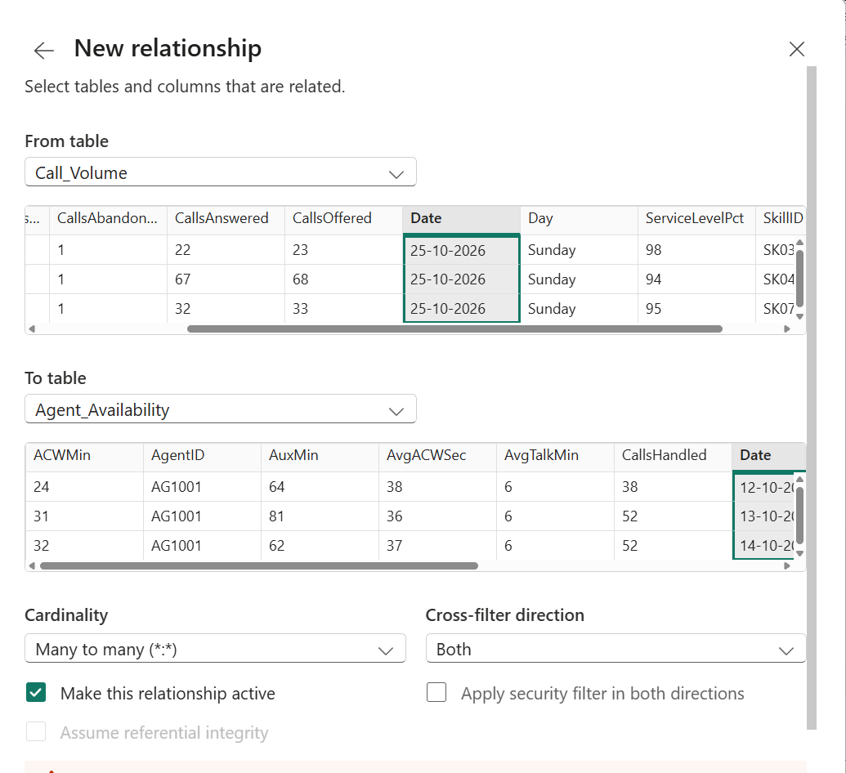
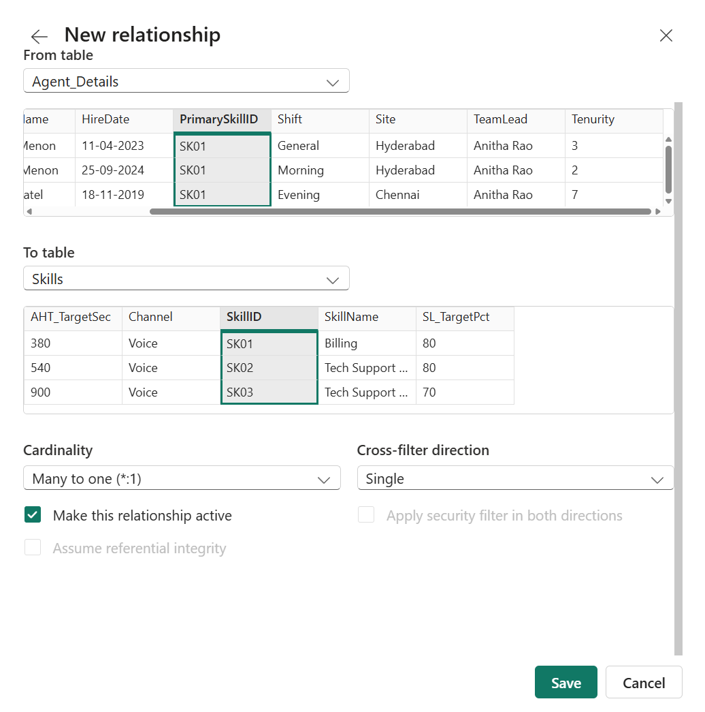

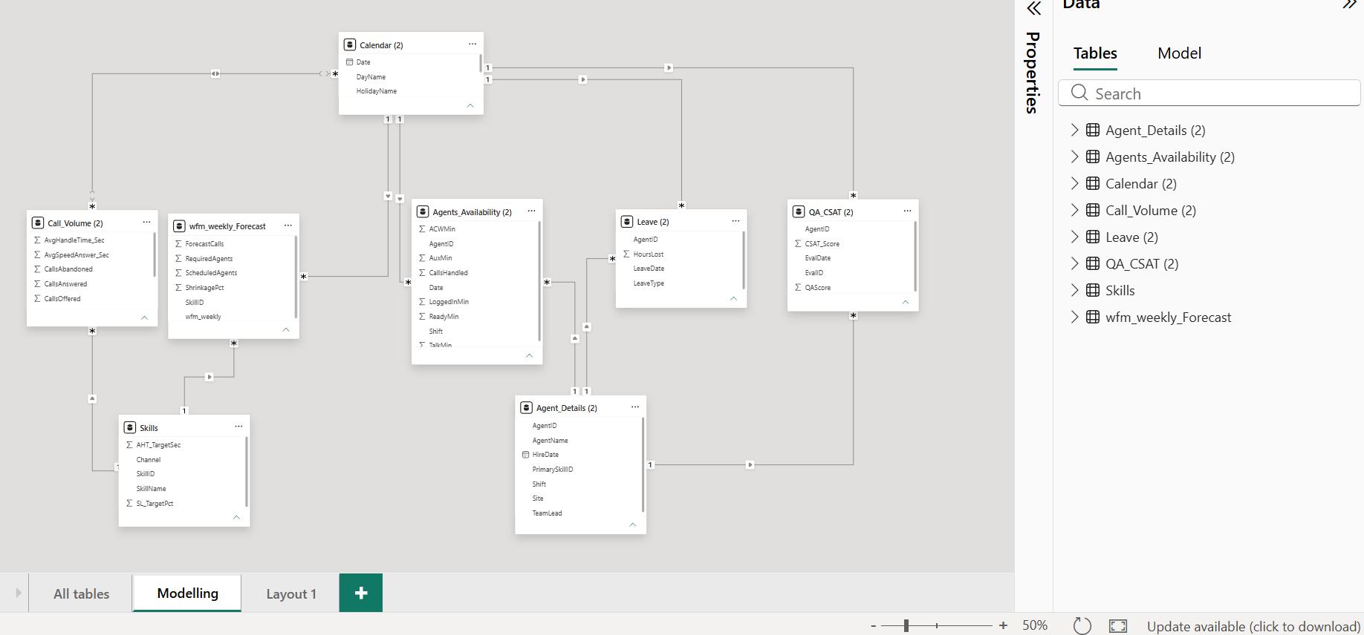

- Date Table Designation: Formally marked Calendar (2) as the official Date Table using the Date field.

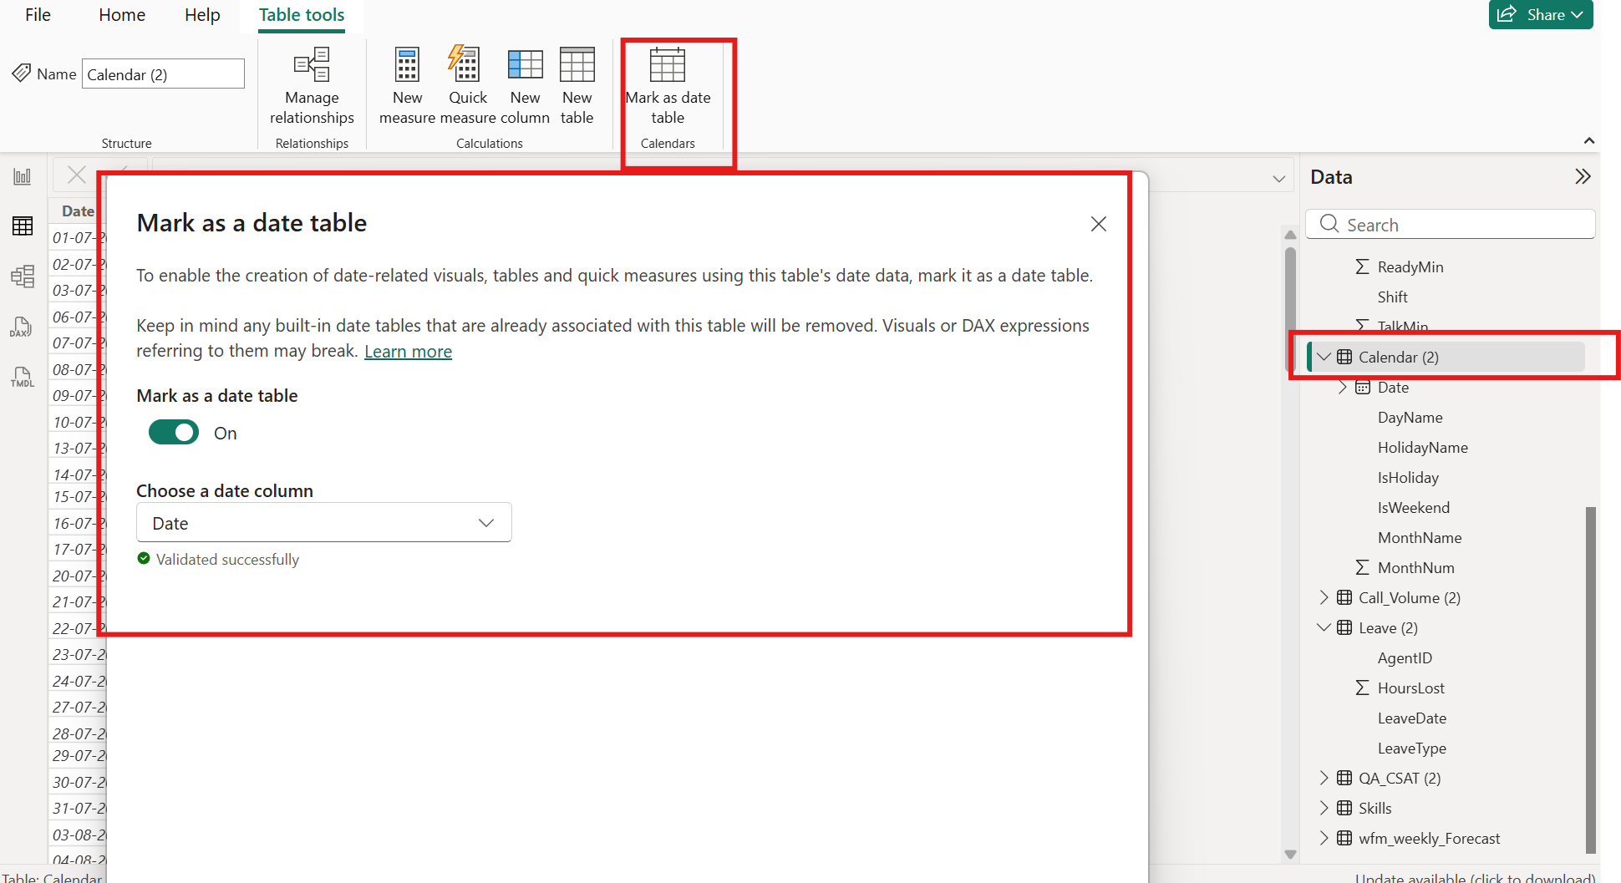

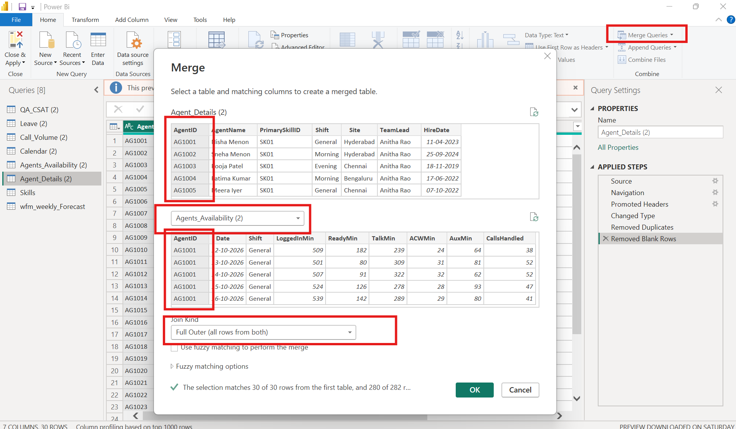

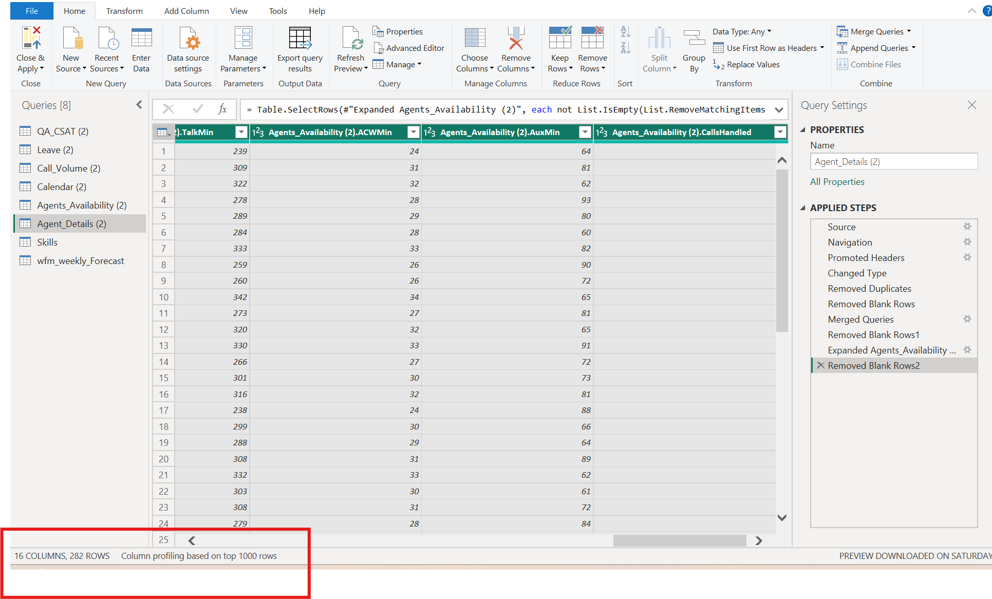
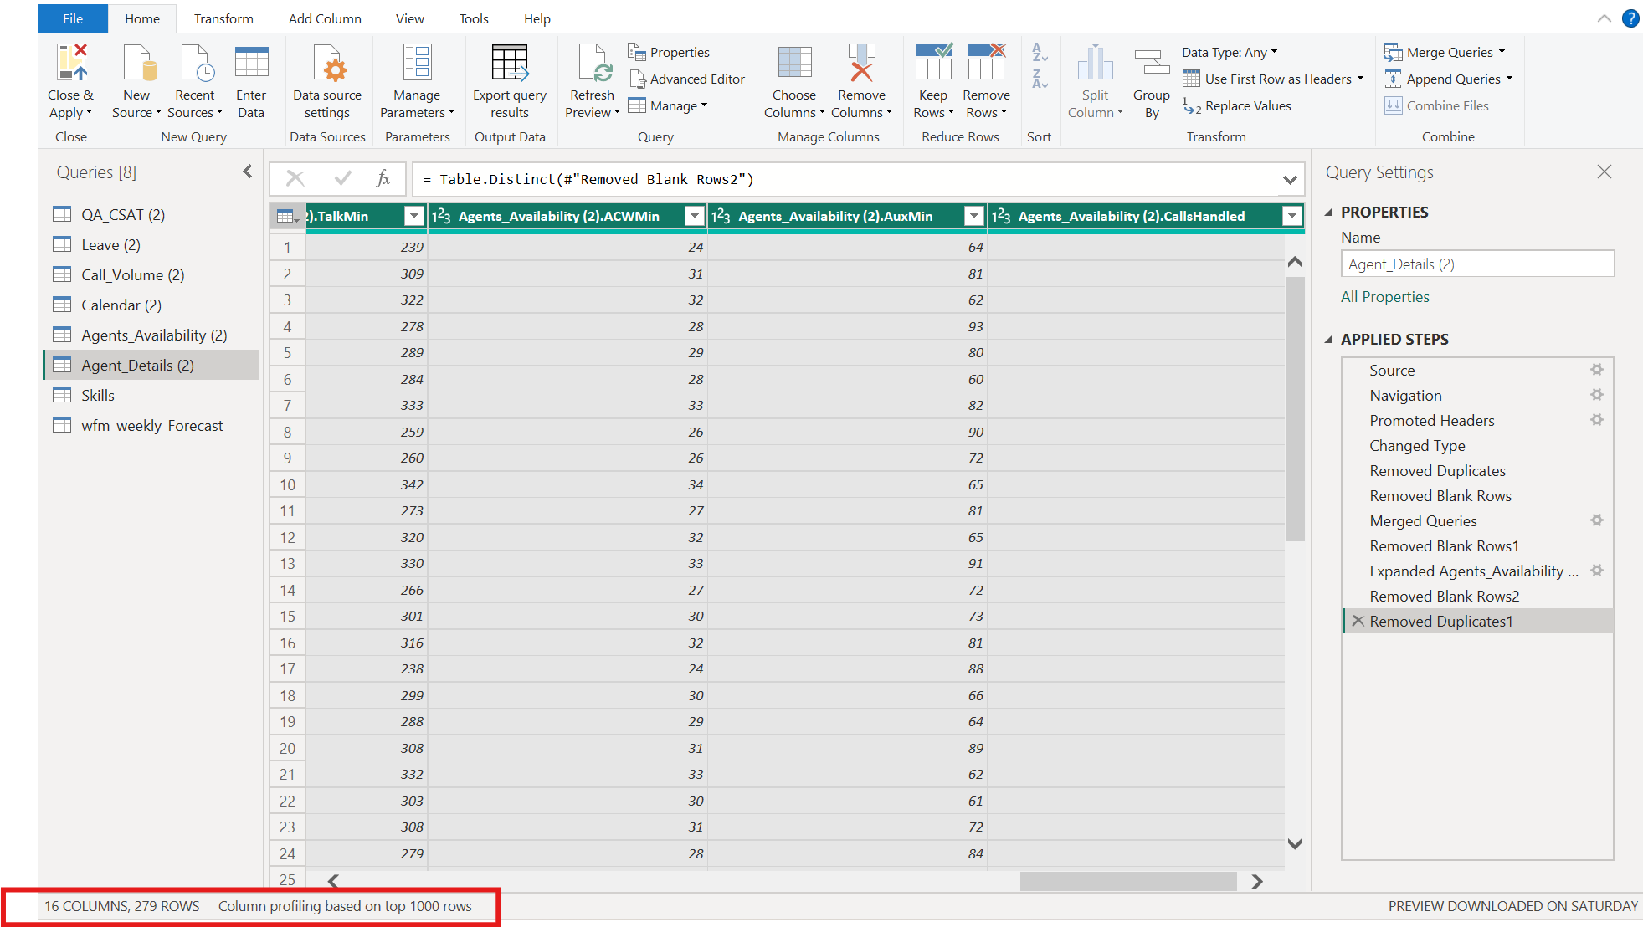
Dashboard Design & Visual Canvas Construction
I authored and structured four specialized reporting tabs to deliver targeted insights for operation leads and workforce planners.

Tab 1: Call Analysis Dashboard
Focuses on high-level volume metrics, agent breakdown, and skill distribution.
- Configured circular KPI cards displaying Total Calls Offered (93K), Total Calls Answered (89K), Total Calls Abandoned (3K), and Abandon Rate % (0.04).
- Built line charts for agent level call handling and stacked bar charts for volume breakdown across months.

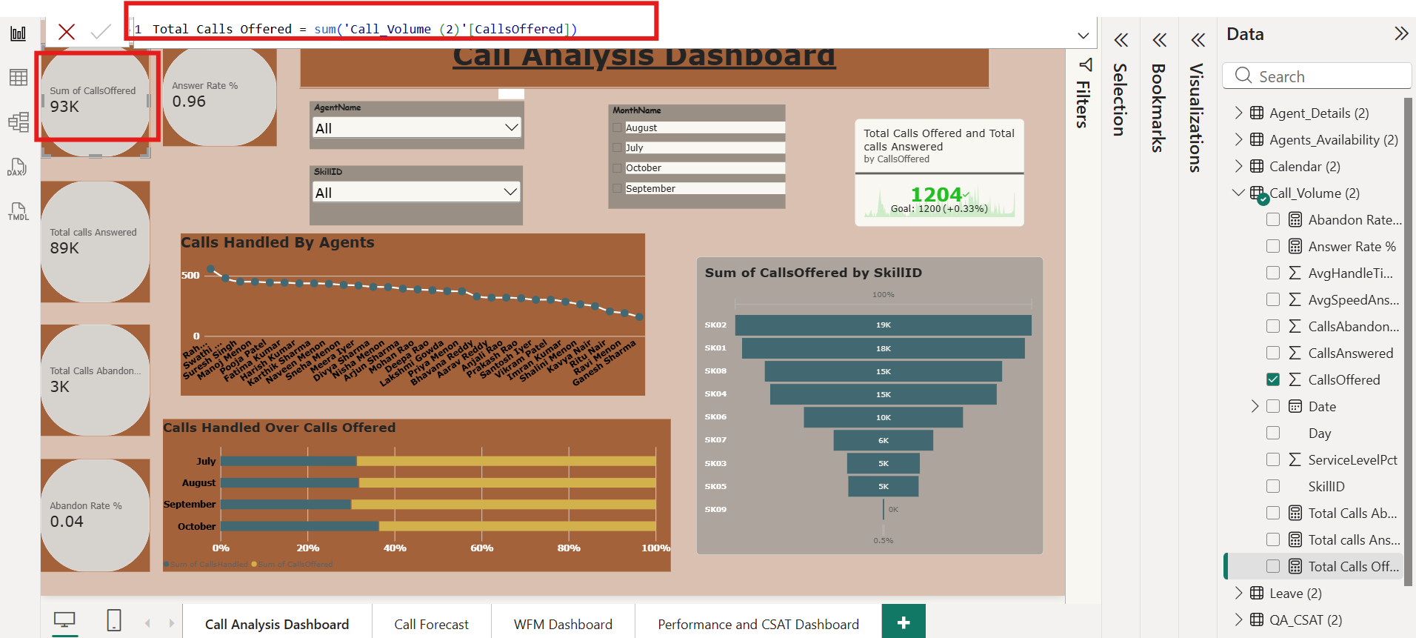

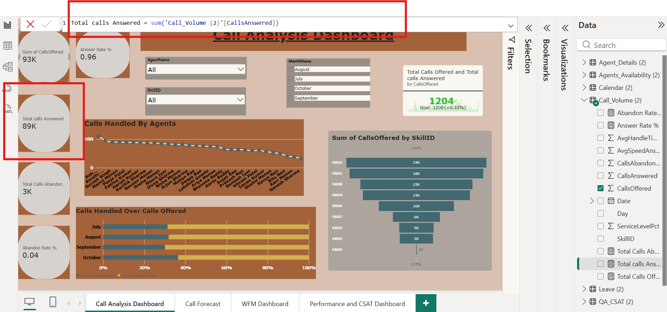

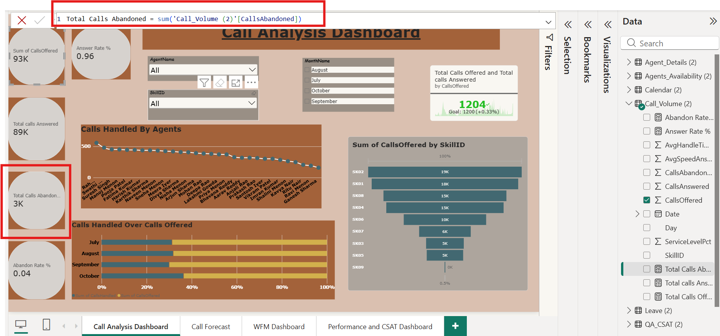

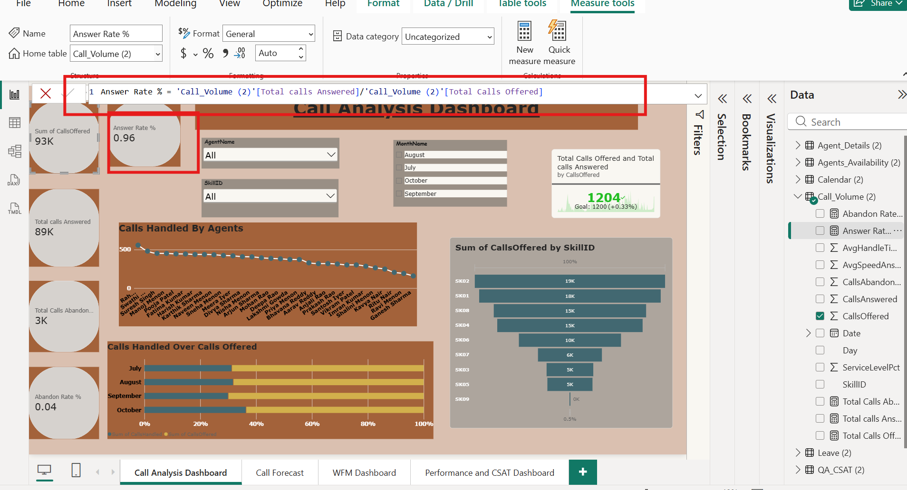

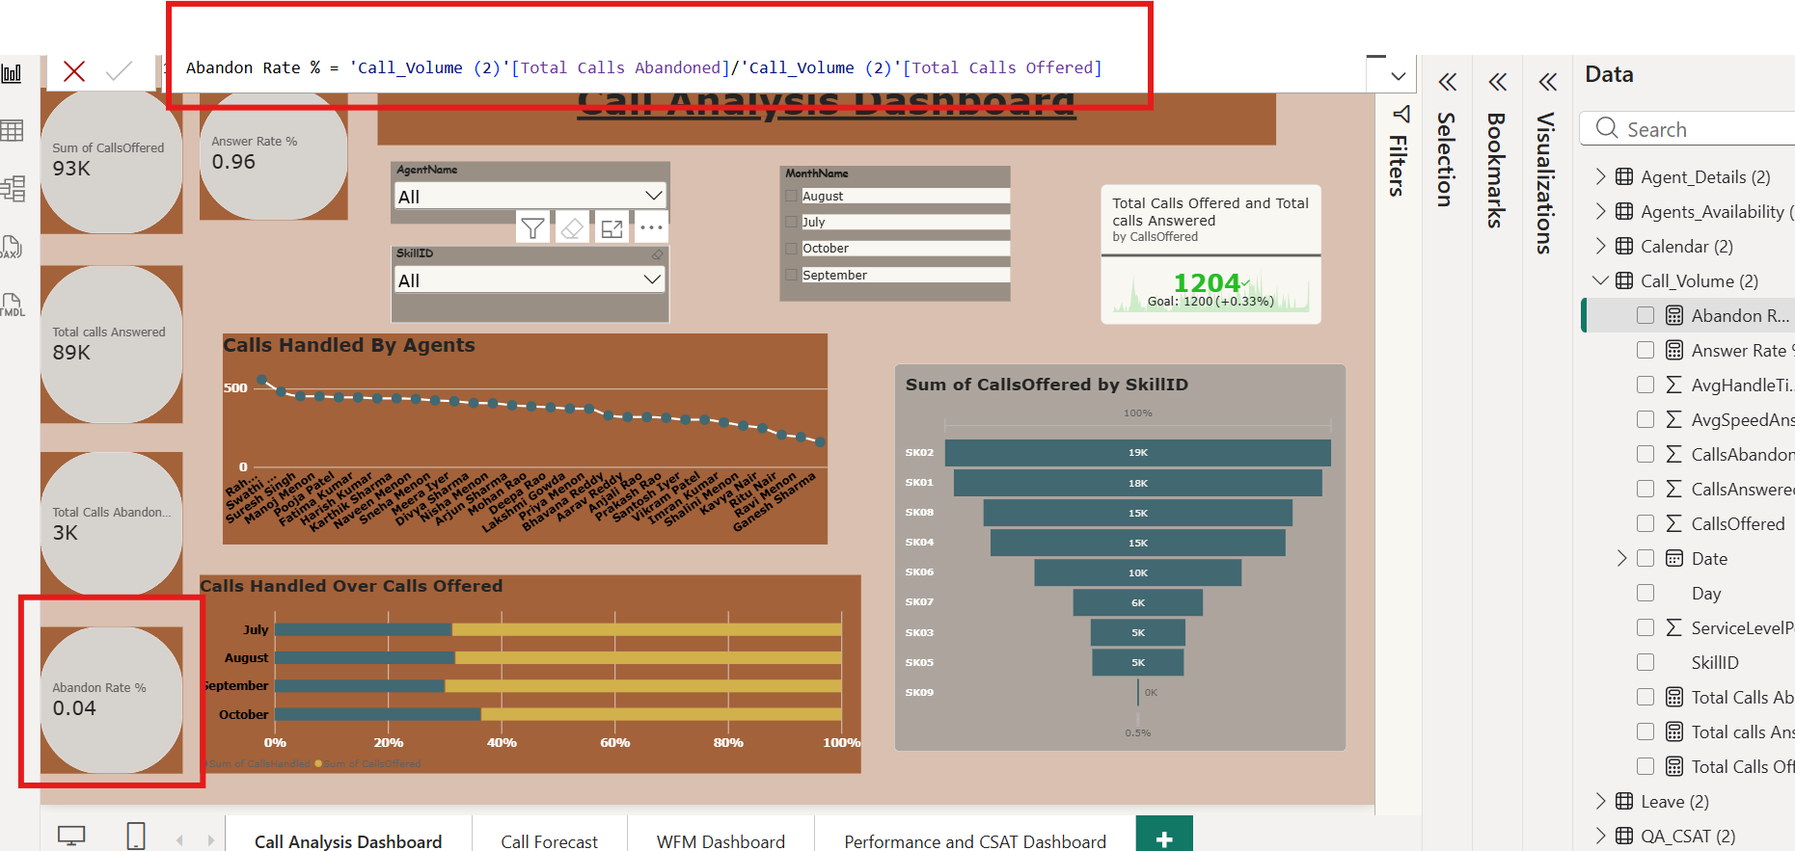

Tab 2: Call Forecast Analysis
Compares forecasted workload against actual volume to evaluate planning efficiency.
- Added KPI summaries for Forecast Calls (86K), Forecast Variance (7K), and Calls Offered (93K).
- Created trend comparison lines for Calls Offered vs. Calls Answered, and bar charts for Shift performance.

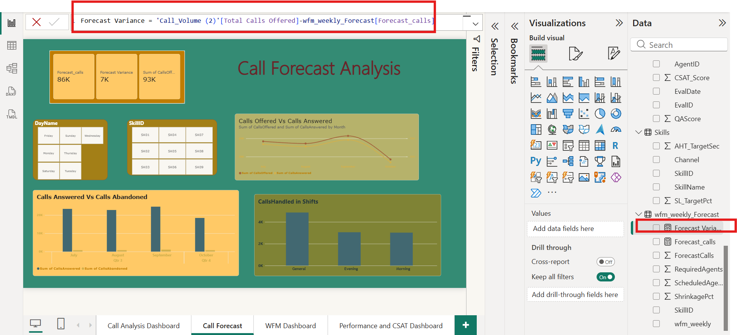

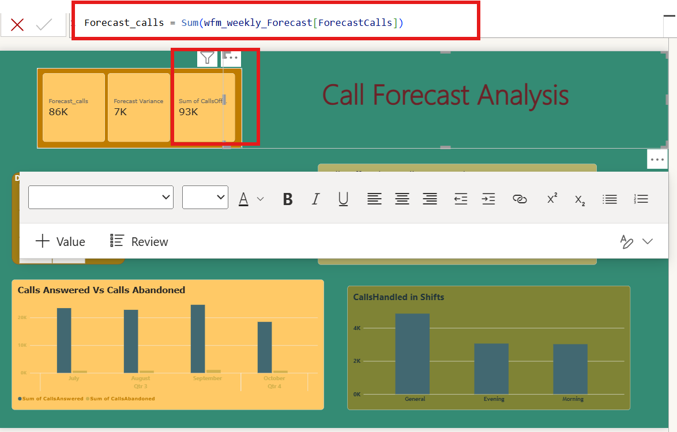

Tab 3: Workforce Management (WFM) Dashboard
Tracks agent attendance, leave distribution, shift schedules, and operational availability.
- Integrated tabular views of agent rosters alongside KPI callouts for Total Days (117), Working Days (83), Weekends (34), and Holidays (5).
- Designed donut chart summaries for Leave Type breakdown and combo charts for Required vs. Scheduled Agents.
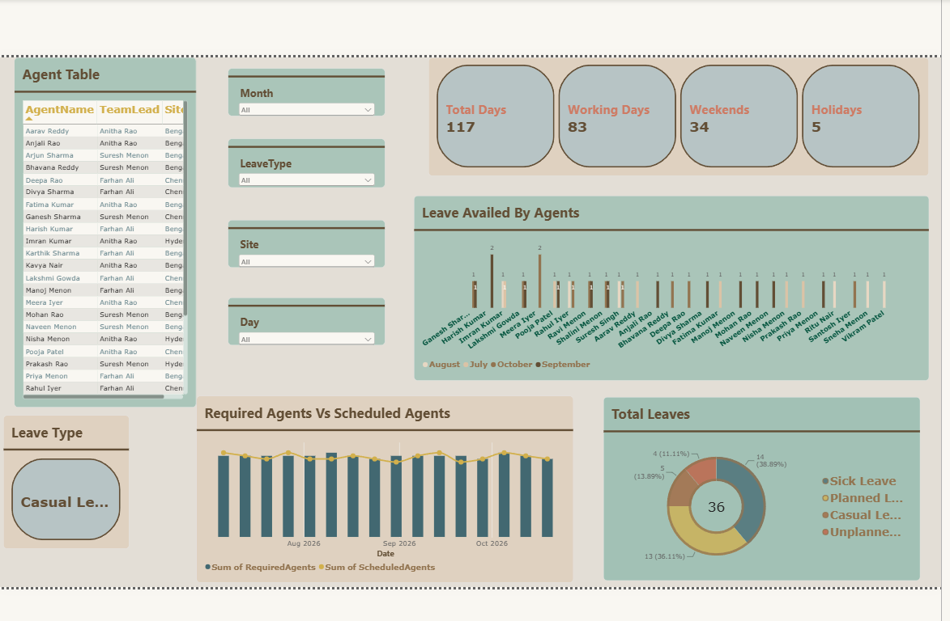

Tab 4: Performance & CSAT Dashboard
Evaluates customer satisfaction metrics, QA evaluation scores, and agent activity distribution.
- Constructed a CSAT Score Gauge visual calibrated against a target threshold.
- Integrated a stacked bar graph displaying active agent time breakdown (Logged In, Aux, Talk, Ready, and ACW minutes).
Configured bar chart visuals tracking QA Scores by evaluating ID across individual agents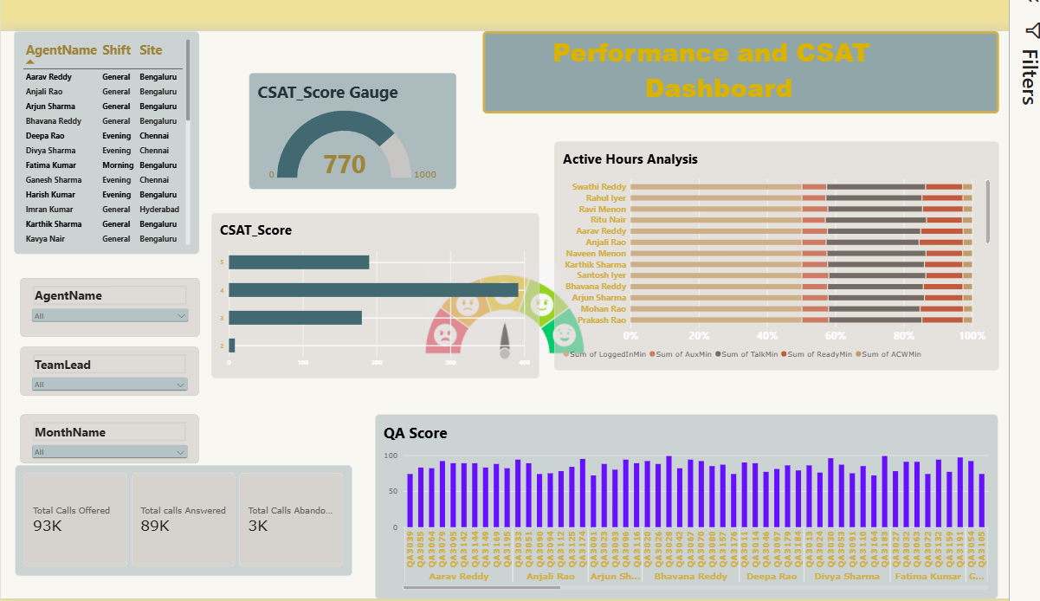
Summary of Results Delivered
By following these structured implementation steps, I successfully built a robust, fully dynamic Power BI reporting ecosystem. The resulting dashboard empowers management to monitor operational efficiency, audit forecast accuracy, track workforce availability, and maintain quality assurance standards seamlessly.

